**Electronics 101 Series**

**Deploying MQTT Broker (Mosquitto) on EC2**

**Authored By**

Unnati Babruwad

Nimisha Honnalli

Ritu Hiremath

Amrut Maliye

1)Login to your AWS Console (via AWS Educate Account)

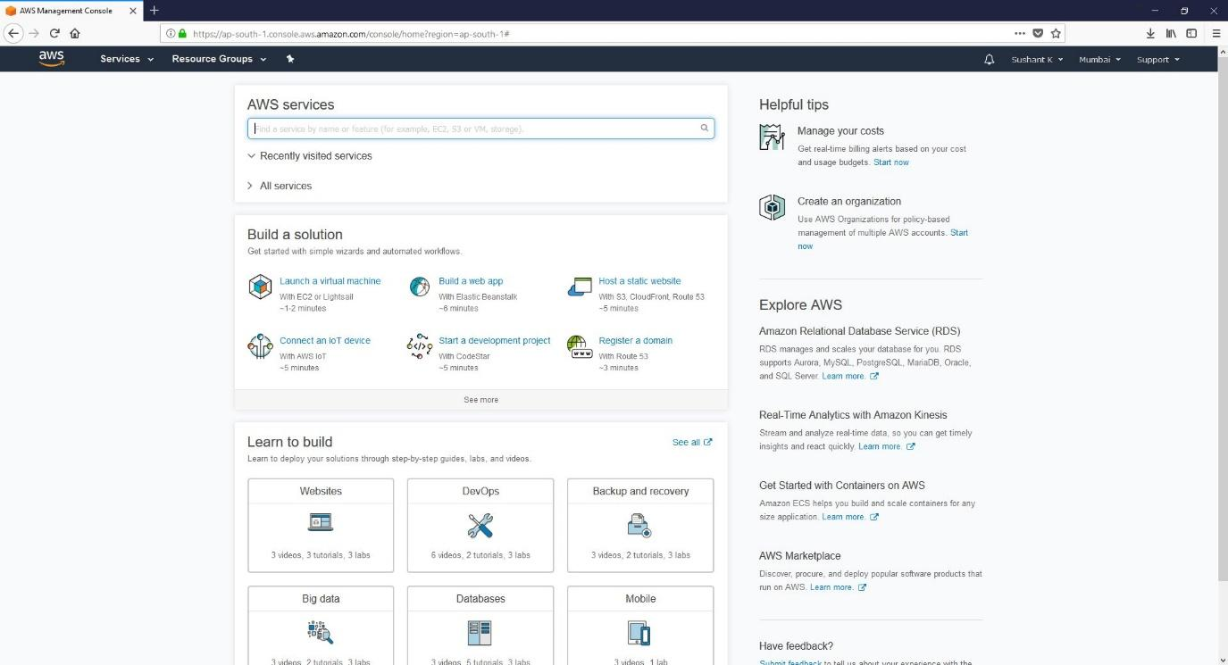

2) Once the window opens, click on Launch Instance

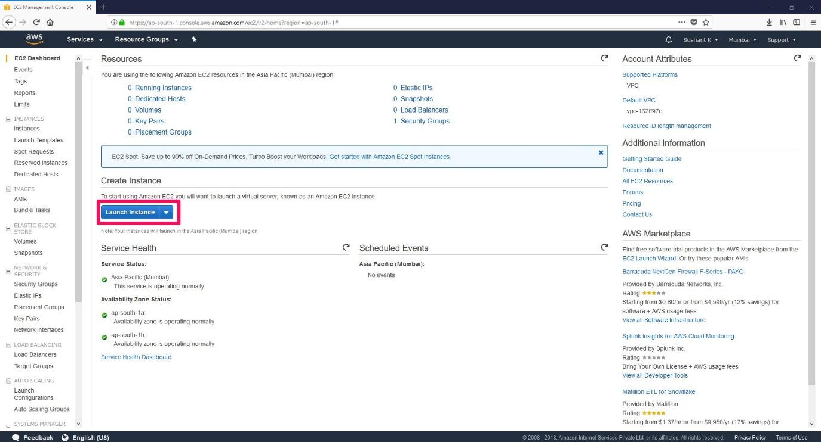

3) In Step 1 - Choose an Amazon Machine Image(AMI). AWS will now ask you for an operating system for your instance, choose Ubuntu Server 16.04 LTS (HVM), SSD Volume Type and click “Select”

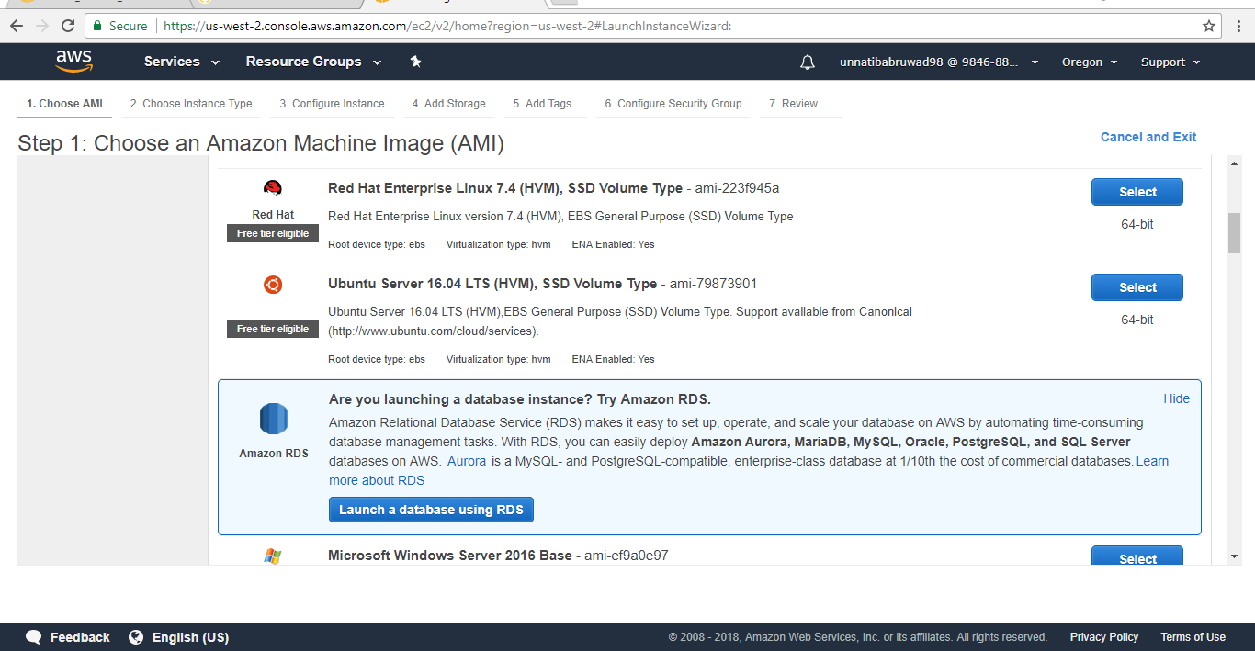

4) In Step 2 – Choose an Instance Type, Choose General Purpose t2.micro. There would be label called Free tier Eligible just below it. Then click on Next: Configure Instance Details

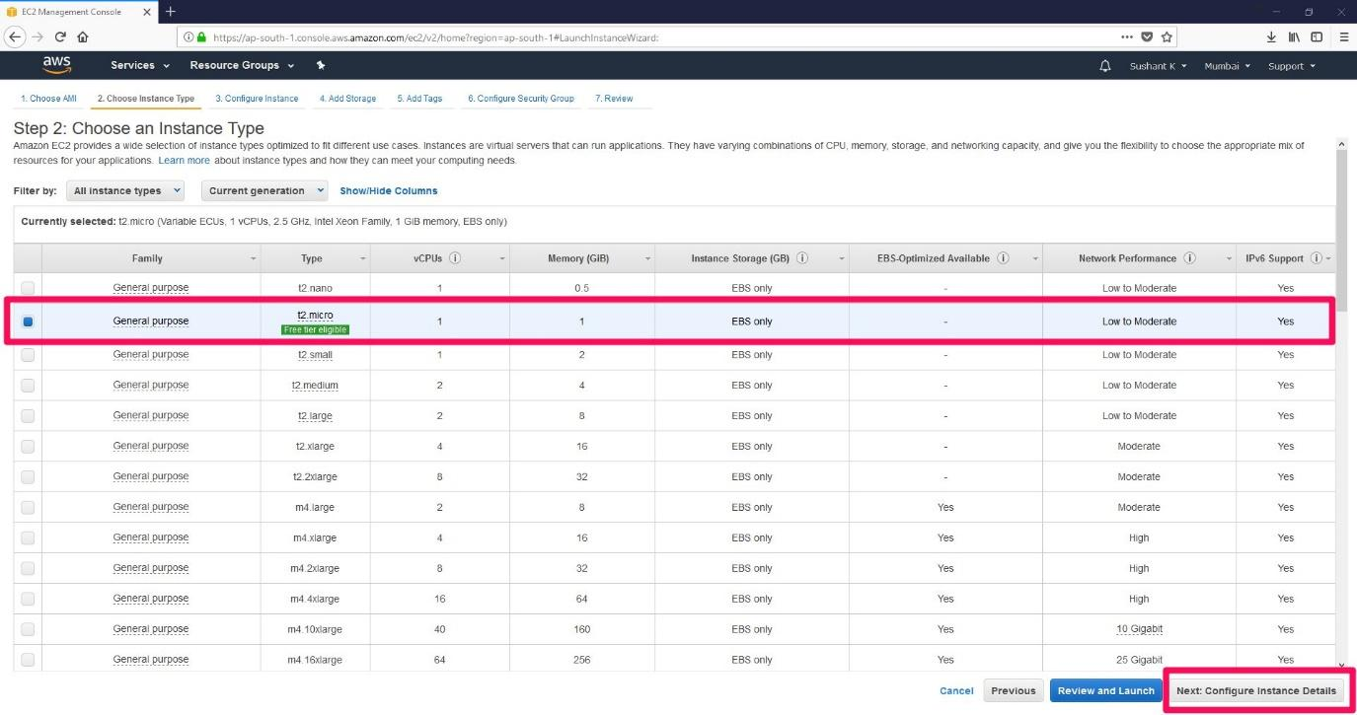

5) In step 3 – Configure Instance Details make sure all the settings are as in the image,

Number of Instances – 1  
Shutdown Behavior – Stop  
Tenancy – Shared  
T2 Unlimited – Unchecked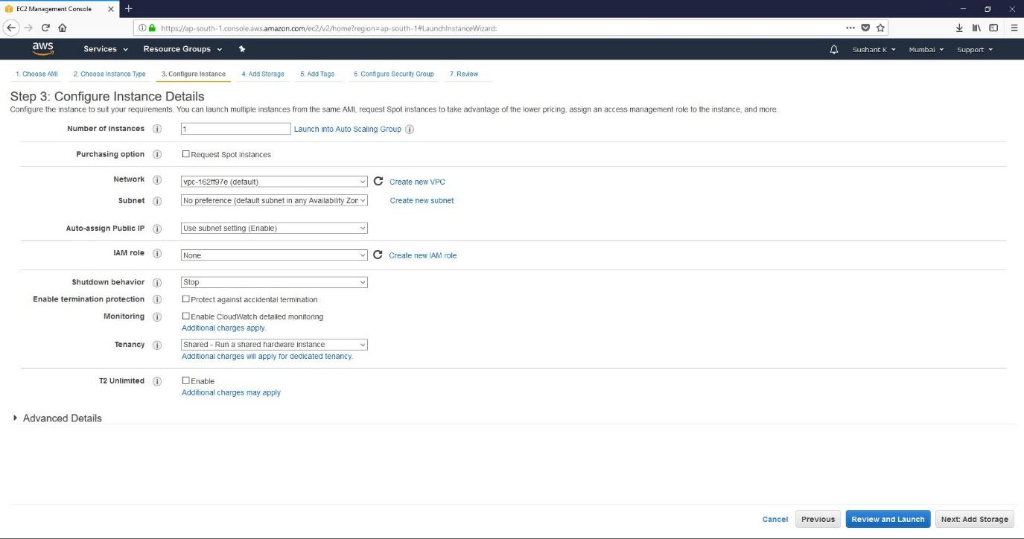

Then click on Next: Add storage

6)In Step 4: Add Storage, you can configure storage (disk space) according to your requirements. By default, it would be 8 GB which is more than sufficient for any project. 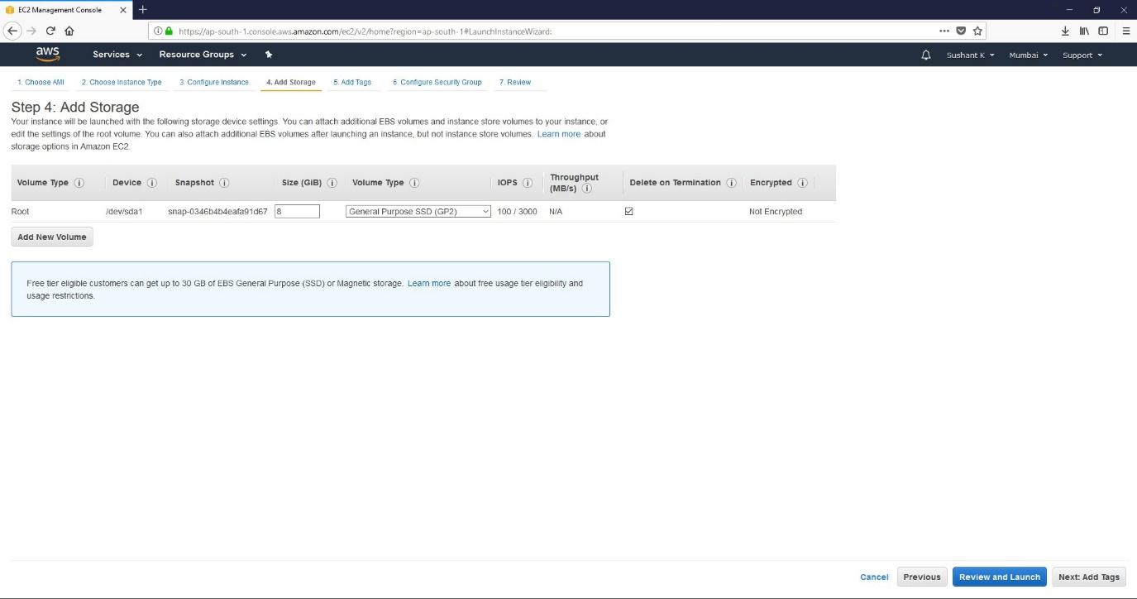

Then click on Next:Add Tags

7) In Step 5:Add Tags, you need not do anything. Directly go to Next: Configure Security Group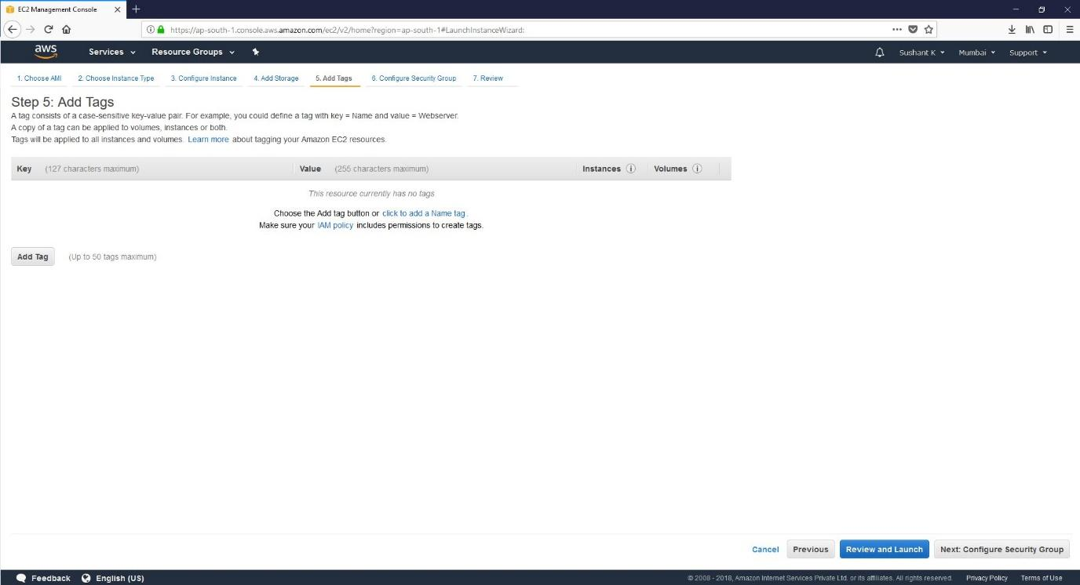

8) In Step 6: Configure Security Group you will be asked to create a new security group with inbound rules for your server. If not configured correctly, the access to server will be restricted.  
Add a SSH rule with source as 0.0.0.0/0

Add a Custom TCP rule with port range 1883 and source as anywhere

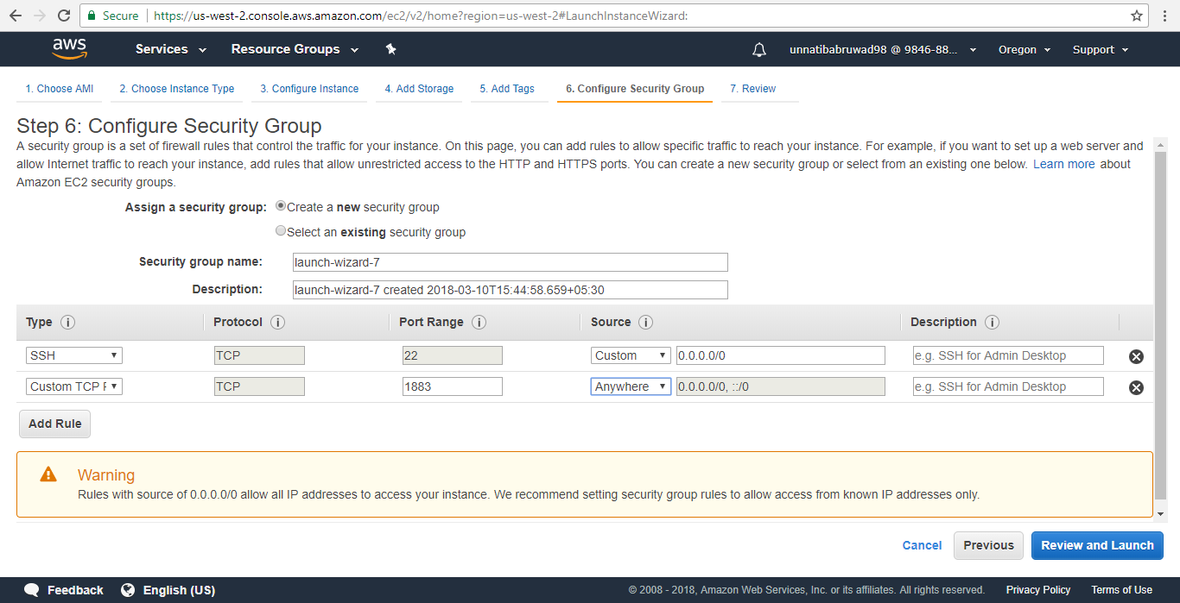

Then click on Review and Launch

9) You will be asked to Review the configuration before your launch it. If everything is as per above configuration, click on Launch

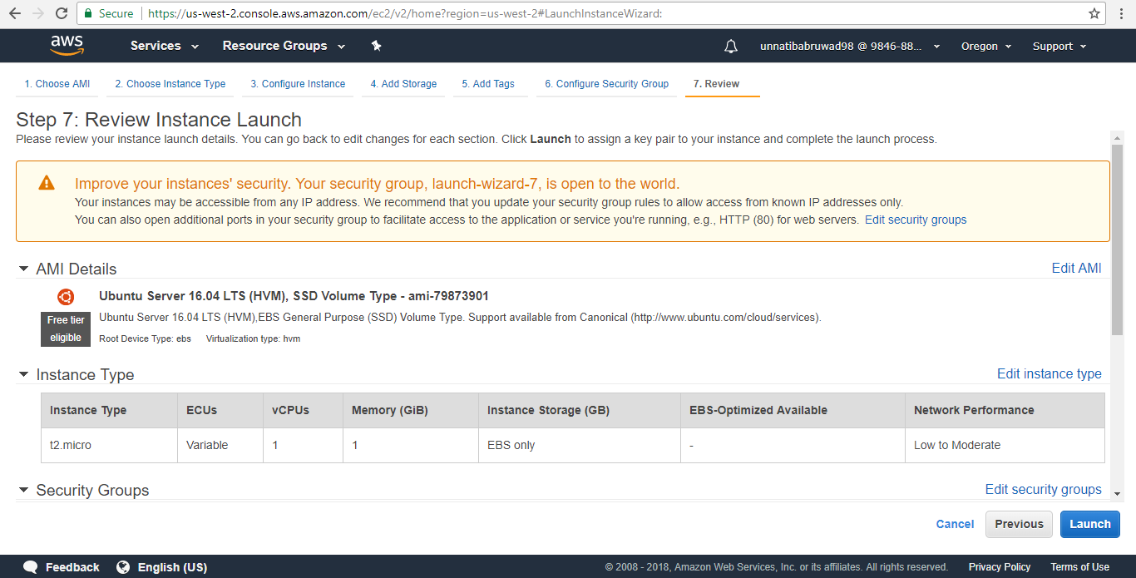

10) You will now be asked to select an existing key pair or create a new key pair. From the first dropdown, choose the option “Create a new key pair”, you can keep the name anything you want.

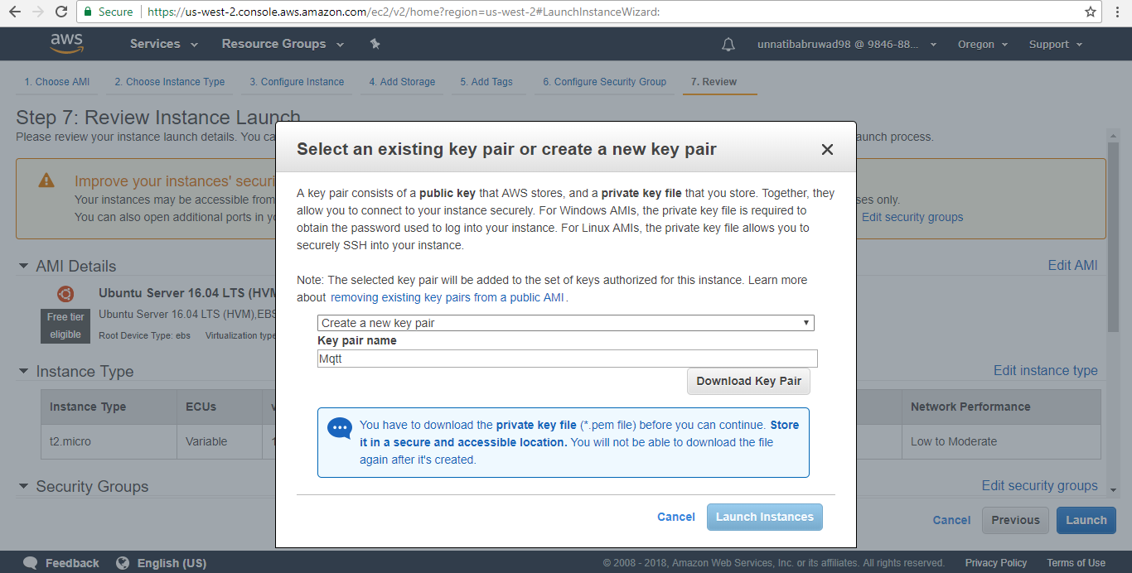

11) If the instance is created successfully, the below window should appear.

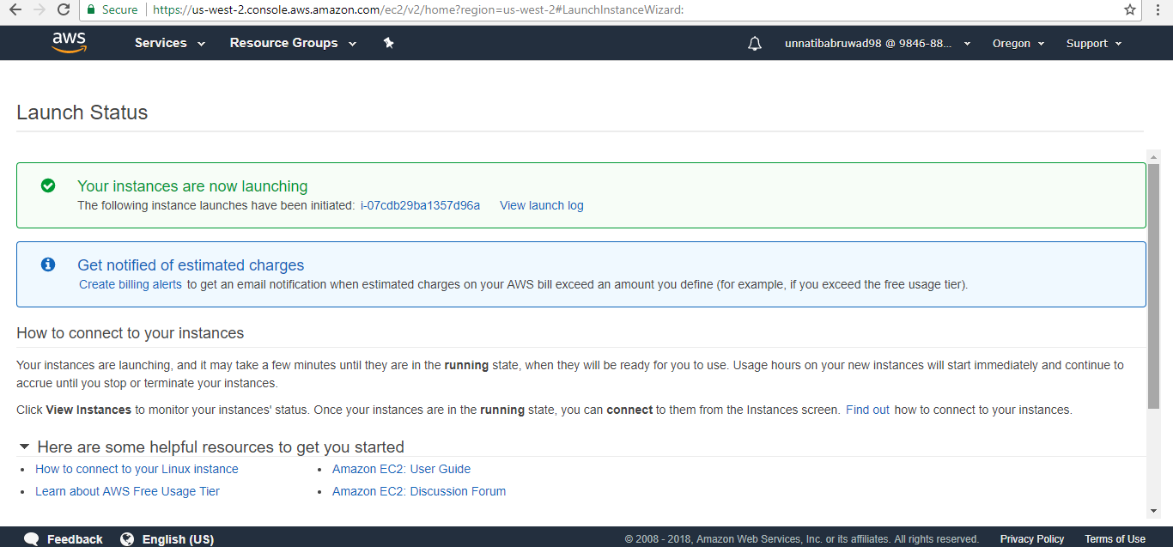

12) After a couple of minutes, the state of the instance will change to running.

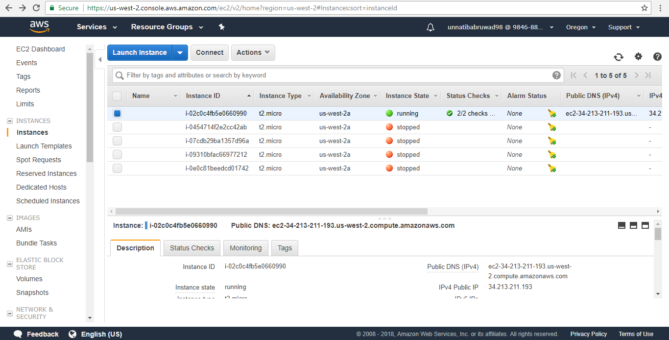

1. PuTTy supports .PPK files. The key pair file you would have downloaded during creation of an instance would be in the .PEM format, hence it is to be converted to .PPK format
   1. Open PuTTYgen (PuTTY Key Generator). Under Conversions, click on Import key and load the key from path where you had saved it

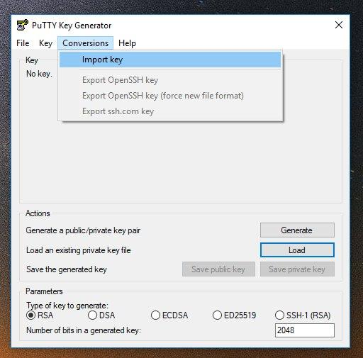

* 1. Then click on Save private key and save it to your pc. It may ask if you are sure to

save this key without a passphrase. Click Yes.

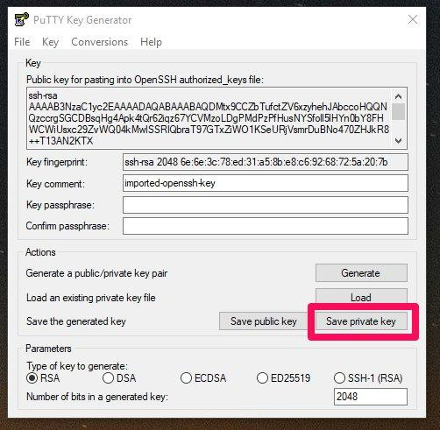

1. Once the .PPK file is saved on to your system, open AWS Console and make a note of the Public DNS for your instance. We will be using this to connect to your instance.

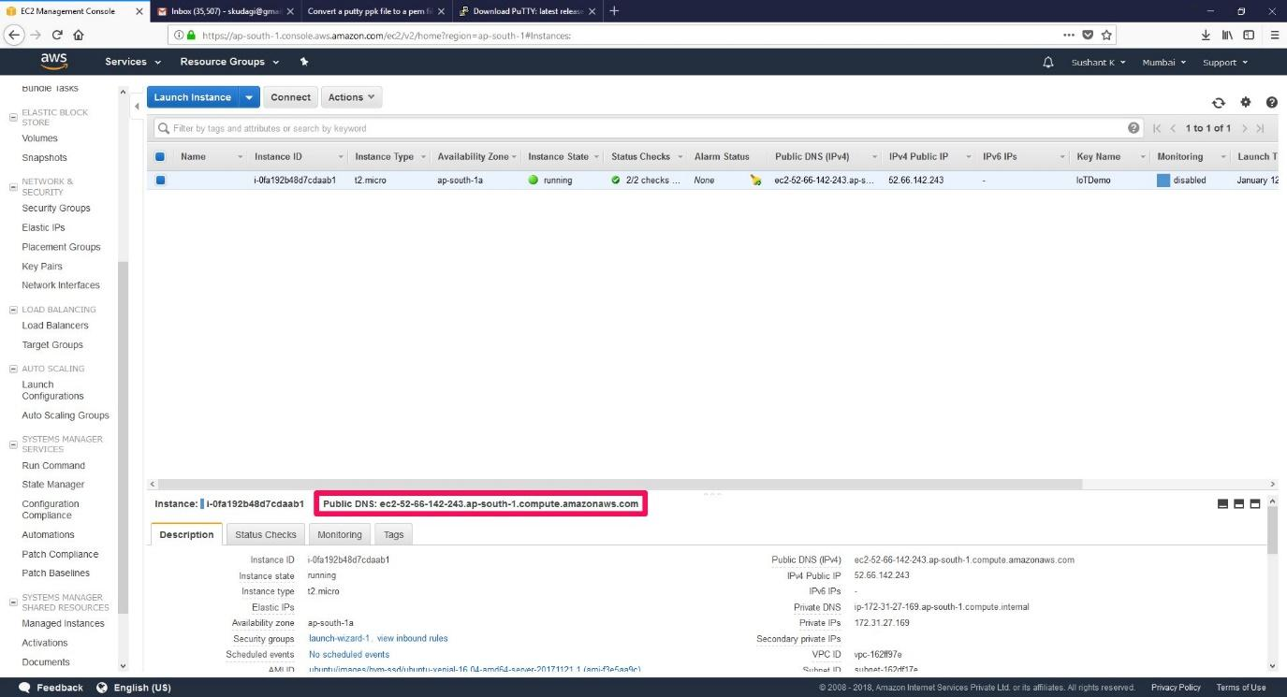

1. Open PuTTY, Under Host name, write your Public DNS address and choose connection type as SSH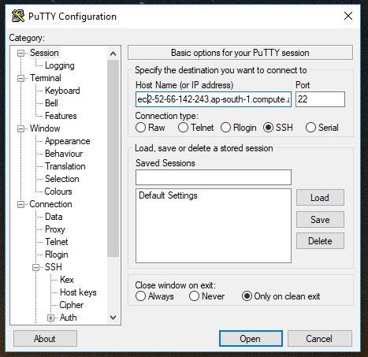
2. Under Connection, Data type the Auto-login username as **ubuntu**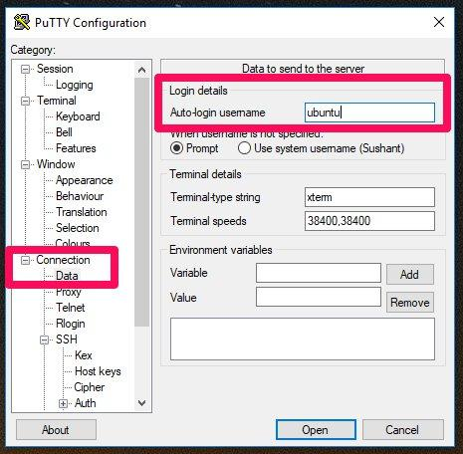
3. Under Connection, SSH click on Auth, choose the Private key (.PPK) file you had created earlier.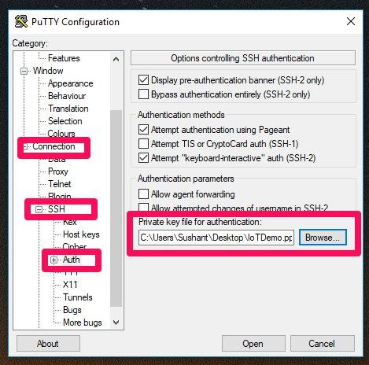

Then Click on Open

For a warning like below, Click on Yes.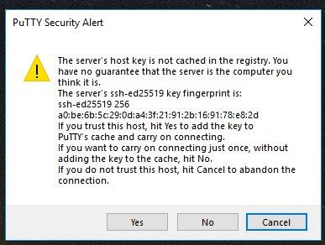

1. If the server connects, you will get a window like below.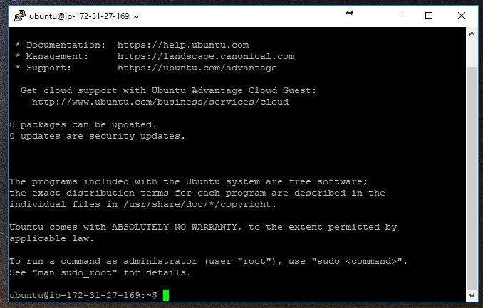

Type the following Commands

* **sudo apt-add-repository ppa:mosquitto-dev/mosquitto-ppa**
* **sudo apt-get update**
* **sudo apt-get install mosquitto**
* **sudo apt-get install mosquitto-clients**

Congratulations! You have successfully deployed EC2 instance as MQTT Broker